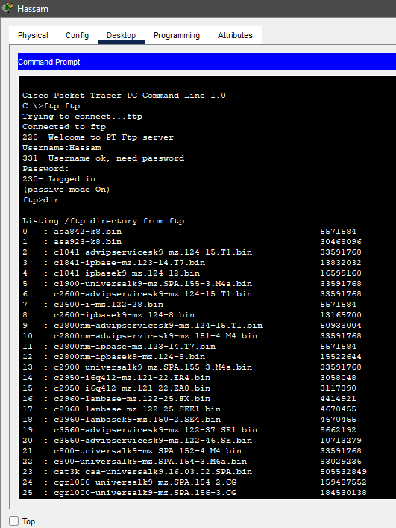

## VOIP Working:

